**Connecting to eduroam on a Mac laptop**

You will first need to configure your laptop in order to connect to eduroam. To do this you will need to download and install a configuration tool. This can be done by connecting to the StrathWifiSetup network available in the Library and Student Residences. The following instructions show the steps for doing so on a Mac laptop. Different versions of Mac may vary slightly in layout but the process will remain the same. You will only need to configure your device once and thereafter it will automatically connect to eduroam.

3. Open a browser and enter cat.eduroam.org into the address bar. Click on Click here to download your eduroam installer.

2. In the drop-down menu, click on StrathWifiSetup.

1. Click on the wifi icon.

5. Click on University of Strathclyde.

4. In the pop-up window, enter University of Strathclyde.

6. Click on Download your eduroam installer Apple device.

7. In the pop-up box that appears, click on Allow.

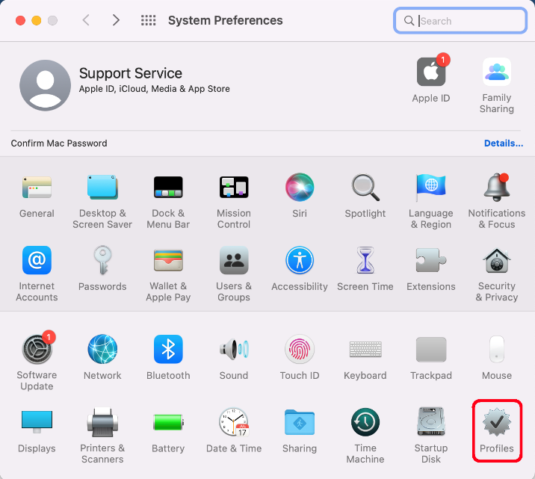

8. On the toolbar, click on the Systems Preferences icon.

9. In the System Preferences window, click on Profiles.

10. Click on Install….

11. In the pop-up window that appears, click on Continue.

12. Where it says Username, enter your DS username followed by @strath.ac.uk. For example, bsb09111@strath.ac.uk.  
  
Where it says Password, enter your password.  
  
Click on Install.

13. Click on Install.

14. You may be asked to enter your macbook password. If so, enter it, then click on OK.

15. Click on the Back button.

17. Click on Advanced….

16. Click on Network.

18. Select StrathWifiSetup, then click on the Remove icon.

19. Click on OK.

20. Click on Apply.  
  
You will now automatically connect to eduroam.

Was this information helpful?

**CONTACT US**

**Email**: help@strath.ac.uk **Call**: 0141 548 4444