University of Strathclyde

Waste Management Policy

Version Control Log:

|  |  |  |  |  |
| --- | --- | --- | --- | --- |
| Version | Date | Description | Author | Approval |
| 1 | Sept 2019 | Initial publication | S Bryson | A Ritchie |
| 2 | July 2021 | Updated waste figures and targets | S Bryson | A Ritchie |
| 3 | October 2024 | Document format update, updated waste figures and targets, content review | S Bryson | A Ritchie |
| 4 | February | Amendment to guidance 2.3.2 | S Bryson | A Ritchie |

Contents

1 Introduction 3

2 Policy Aims 3

2.1 The Waste Hierarchy 3

2.2 Procurement of goods and waste management 4

2.3 Refurbishment and reuse of goods 5

2.3.1 Furniture 5

2.3.2 Electrical and Electronic Waste 5

2.4 Construction waste 6

2.4.1 Material selection 6

2.4.2 Construction Waste Reporting 6

3 Plastic Waste Reduction 7

4 Monitoring and Reporting Performance 7

5 Hazardous Waste 8

5.1 Definition 8

5.2 Policy Statement 8

5.3 The University will achieve this by: 8

5.4 Responsibilities 8

5.4.1 The University Secretary 8

5.4.2 Heads of Departments are responsible for ensuring that: 8

5.4.3 Line Managers are responsible for: 9

5.4.4 Estates Services Department is responsible for: 9

5.4.5 The University Safety, Wellbeing and Resilience department is responsible for: 9

5.4.6 Staff are required to: 10

6 Accepted materials and Recycling 11

7 What Happens to Our Waste? 15

7.1 Dry Mixed Recycling 15

7.2 Food waste 16

7.3 General waste 16

# Introduction

This Waste Management Policy forms part of the University’s sustainability framework and helps support the University’s Climate Change and Social Responsibility Policy:

<https://www.strath.ac.uk/sustainablestrathclyde/policyguidelines/>

The policy’s aim is to reduce negative environmental impacts arising from our generation of waste, seeking to prevent, reuse, repurpose and reduce waste from our operations. The Policy also aims to ensure that the University manages waste issues in accordance with prevention of pollution guidelines and compliance with environmental legislation at all times. It is particularly aligned with SDG 12: Responsible Consumption & Production.

The University is committed to implementing an effective and responsible waste resource management process that meets and ideally exceeds legislative, regulatory and best practice legislation and guidance. The University has a “Duty of care” to effectively manage waste, and this is a legal obligation to ensure the safety or well-being of others.

# Policy Aims

The University adopts the ‘waste hierarchy’ of prevention, reuse, recycling, other recovery and disposal. The University implements processes, procedures and initiatives that ensure compliance with environmental legislation and best practice and which encourage waste producers to reduce the overall waste that they produce, and prevent waste production wherever possible.

All staff, students and visitors are required to follow the guidance provided within this policy and locally across university facilities to minimise the generation of waste wherever practicable and comply with all legislative requirements on the safe reduction, storage, handling and disposal of waste. Any queries related to waste management should be first taken up with line managers, heads of department or the University Waste & Environmental Compliance Manager.

## The Waste Hierarchy

The waste Hierarchy exists to guide waster producers on how to manage waste materials, from the most preferable option (prevention) to the least preferable option (landfill). The steps of the waste hierarchy should always be followed when considering the disposal of goods and materials in the University.

**Stages Includes**

Using less material in design; keeping products for longer; using less hazardous material.

Preparing for re-use; cleaning; repairing, refurbishing.

Turning waste into a new substance or product, including composting.

Anaerobic digestion – conversion to biogas for electricity generation; incineration with energy recovery.

Landfill and incineration without energy recovery.

The University has robust and comprehensive recycling infrastructure throughout the Estate. All staff and students are encouraged to make use of these facilities in order to help recycle as much waste as is possible.

## Procurement of goods and waste management

When procuring goods for the University, staff are required to consider the end-of-life disposal of the goods to ensure resources are managed in line with the waste hierarchy.

For most procurement activity, this will involve, as a minimum:

* Are there alternative products that could be purchased that would consume less material, allow easier repair and reuse of the product, or allow for easy disassembly into component parts to enable recycling?
* Does the supplier of the goods have a take-back scheme for the purchased products which will allow materials to be reused or refurbished? If so, details to be obtained during procurement and passed to the department receiving the goods.
* Are there suppliers (original, or alternative) that can reuse the goods as-is, or refurbish the goods to put them back into circulation (either at the University or elsewhere? If so, details to be obtained during procurement and passed to department receiving the goods.
* Identifying the disposal route for the goods purchased – can the goods being purchased be recycled through current University waste management systems, or is a specialist waste disposal route required? If so, ensure department purchasing goods is aware of correct disposal routes and how to access them.

## Refurbishment and reuse of goods

Once goods have been purchased and used by the University, reusing goods to extend their lifecycle forms a key part of the approach to reducing waste. There are several channels currently available for reuse of goods as they are, and options available for refurbishment of goods.

### Furniture

When the need for new furniture is identified, staff should first consider reuse of existing furniture within the department. Where no surplus furniture is available, please contact the sustainability team [sustainability@strath.ac.uk](mailto:sustainability@strath.ac.uk) with details of the furniture you require, as surplus furniture may be available elsewhere in the university or in storage that is available for deployment.

Where the department is aiming to replace existing furniture that is broken, before buying new the department should utilise lot 3 of the APUC Sustainable Furniture Framework which contains a list of suppliers which specialise in refurbishment and repair of furniture. This can often be done one site, or collected, repaired and returned where required. Repairs can include reupholstery, carpentry repairs, replacement parts, recovering of desks and storage units, and resizing of desks. This will achieve both financial savings for departments but also reduce carbon and environmental impacts of furniture, contributing to Net Zero goals and KPI 16.

When furniture is required but none is available elsewhere in the university or to be repaired, it must be procured through the Sustainable Furniture Framework agreement published by the APUC. When purchasing furniture. Initial queries to suppliers should be for refurbished furniture. Under the framework agreement, refurbished furniture must meet “like-new" standards and comes with guarantees to protect buyers, but represents significant savings in terms of purchasing costs to departments and carbon footprint of goods.

### Electrical and Electronic Waste

When IT equipment is no longer required, it should first be highlighted to Information Services or your Faculty IT Support Team to check if this can be reused within the University. In the event equipment cannot be reused, the university Waste Electrical and Electronic Waste (WEEE) contractor should be contacted to arrange collection and disposal. Please see Waste A-Z for contact details.

The University WEEE contractor will complete secure data erasure on any devices with data storage, and if the devices are in a functioning state, will arrange for the reuse of these items, extending their lifecycle and reducing waste.

## Construction waste

The University Waste Management Policy also includes the need to consider end of life disposal costs and environmental impact when making procurement decisions including the construction of new or refurbished buildings.

### Material selection

Materials used in construction and refurbishment projects should take into account their ability to be reused and recycled, and the levels of recycled and low-environmental impact content. Contractors are encouraged to provide information on sustainable and lower-impact materials during tender and preconstruction phases to assist the university in reducing its environmental impacts. This includes:

* Providing the option of alternate materials which contain a high percentage of recycled content compared to industry standard
* Only including the use of timber products which are covered by an environmental or sustainability certification, such as FSC, PEFC, SFI.
* Providing the option of materials and manufacturing methods designed for or enable deconstruction and reuse, such as modular units, avoidance of composite materials where practicable to allow ease of reuse or recycling, materials with high salvageability and reuse value, avoidance of adhesives and nails inn favour of removable fixings where practicable.
* Provide alternative materials with lower environmental impacts, such as low VOC paints, sealants, fittings and fixtures.

### Construction Waste Reporting

Contractors undertaking construction or refurbishment work for the university must:

* If, removing their own waste from site, provide a copy of their waste Carrier’s Licence to the project team and the University Waste and Environmental Compliance Manager. Details of where waste is taken to must also be provided.
* If utilising a waste management contractor for the removal of waste, provide a copy of their Waste Carriers Licence and a copy of the Waste Management Licence (WML) for the site the waste is taken to. This must be a FULL copy of the WML including all site details and accepted materials, not just the cover page.
* Keep copies of all waste transfer notes (WTNs) and make these available to the university for inspection within a reasonable timeframe when requested. WTNs must be held for a minimum of 2 years (or 3 years if transporting special/hazardous waste).
* As the end of projects, provide a report to the project team and the University Waste & Environmental Compliance Manager detailing all waste removed from site, including Waste type, tonnage and disposal routes (i.e. the percentage of waste recycled, percentage sent to Energy from waste facilities, and percentage landfilled).
* All information should be sent to sustainability@strath.ac.uk

# Plastic Waste Reduction

The University recognises the adverse impact of plastic waste, from production through to disposal. Plastic pollution can have a harmful impact on the marine environment and the University is seeking to reduce plastic use and wastage on campus. The following initiatives have been adopted in order to promote this aim with staff and students:

Single-use plastics in catering (food packaging, disposable coffee cups, cutlery) have been replaced with compostable catering supplies in all University food outlets, in order to reduce plastic waste on campus.

Reusable cups are provided to University staff during staff inductions to reduce single-use disposable cup wastage. These can also be purchased from campus retail outlets and discounts are offered to users when reusable cups are utilised. Single use cups incur an additional charge to encourage a move to reusable cups.

Conferencing and Events utilise reusable glassware to serve water, eliminating waste from previously utilised plastic bottled water. The team also produce purified water on site, reducing waste further by avoiding the need to buy water in disposable packaging. Water stations have been installed throughout the campus for use by students and staff to encourage bottle reuse.

The university aims to continue to reduce waste by exploring new products and services which will assist in achieving reduced plastics usage and waste.

# Monitoring and Reporting Performance

The University’s commercial waste contractor records and monitors the amount of waste that is disposed of and recycled on a daily basis. This includes data on general waste, dry mixed recycling, food waste, glass, green waste, plasterboard, and construction waste generated by the university. This monitoring data includes regular audits of our recycling to ensure that it is uncontaminated by other inappropriate materials. The monitoring data is recorded and reported on a regular basis to internal and external stakeholders including the Scottish Government.

The university also records confidential waste, WEEE, wood, clinical, chemical and battery waste generated on campus. This information is included in annual waste reporting which can be found on the Sustainable Strathclyde webpages [here](https://www.strath.ac.uk/whystrathclyde/sustainablestrathclyde/policiesreports/).

The university commercial waste contract operates on a Zero Waste to Landfill target. While this is an important target included in all waste contracts, work is ongoing to reduce reliance on incineration and energy from waste plants as a method of waste disposal.

# Hazardous Waste

## Definition

Hazardous Waste is waste that can be harmful to health or the environment. It includes infectious biological/clinical waste, chemicals, solvents, pesticides, fluorescent light tubes, refrigeration equipment containing ozone, non-edible oils, batteries, asbestos and paints.

## Policy Statement

The University will manage, so far as is reasonably practicable, all hazardous waste activities falling under its control in a manner such as to minimise the harm to human health or the environment.

## The University will achieve this by:

Producing and communicating procedures to enable employees to comply with their ‘duty of care’ for the management of hazardous wastes, and monitor these procedures to ensure compliance. Applying the waste management hierarchy with the aim of minimising the generation of hazardous waste.

## Responsibilities

### The University Secretary

The University Secretary has responsibility for health and safety matters at the University. The Secretary delegates responsibility for undertaking aspects of these duties through line management and identified roles, namely via the Director of Safety, Wellbeing and Resilience’.

The following people are identified as having responsibilities (in addition to any other responsibilities under other health and safety policy) for the management of hazardous waste in those areas, and for those relevant persons, that fall under their control:

### Heads of Departments are responsible for ensuring that:

* Departmental arrangements for the management of hazardous wastes are put in place, communicated and monitored.
* Competent persons are identified to implement the arrangements for the management of hazardous waste.
* Where practicable, aim to minimise the procurement of hazardous materials to prevent redundant materials needing to be disposed of as hazardous waste.
* Ensure sufficient allocation of appropriate storage facilities for hazardous wastes until such time as it can be collected.

### Line Managers are responsible for:

* Ensuring the management and disposal/recovery of hazardous waste is included in the risk assessments and local procedures for the tasks undertaken by their employees.
* Ensuring that relevant workers are informed of the significant findings of such risk assessments and that local procedures are followed for the management of hazardous wastes.

### Estates Services Department is responsible for:

* Segregation of hazardous waste under their management, such as Estates centrally managed WEEE and asbestos-containing waste, and storing them safely and securely before arranging for their disposal in accordance with relevant legislation.
* Ensuring that staff who may encounter hazardous waste are adequately trained to carry out their duties.
* Maintaining records, at the premises, of hazardous waste consignment notes, consignee returns and any other related documents (such as carrier schedules or rejected loads) for at least 3 years.
* Undertaking periodic ‘duty of care’ audits of licenced waste contractors.

### The University Safety, Wellbeing and Resilience department is responsible for:

* Ensuring that procedures are established to ensure the ‘best available techniques’ for the correct identification, segregation, labelling and storage of hazardous wastes on University premises under its control.
* The production and communication of procedures and guidance regarding the management of hazardous waste, under its remit, on University premises.
* Managing the collection of hazardous waste, under its remit, from University storage facilities by authorised licensed contractors.
* Undertaking periodic ‘duty of care’ audits of licenced waste contractors.
* Maintaining records, at the premises, of hazardous waste consignment notes, consignee returns and any other related documents (such as carrier schedules or rejected loads) for at least 3 years.

### Staff are required to:

* Follow the University procedures to manage hazardous wastes. This includes the correct identification, segregation, disposal and storage of hazardous wastes in dedicated, labelled containers with prompt removal when full. Staff producing waste will be required to sign consignor sections of hazardous waste consignment notes.

# Accepted materials and Recycling

Staff and students are encouraged to recycle wherever possible. Guidance on accepted materials can be found at recycling points throughout the university, and on the University wasteand recycling webpages [here](https://www.strath.ac.uk/whystrathclyde/sustainablestrathclyde/whatwedo/wasterecycling/). 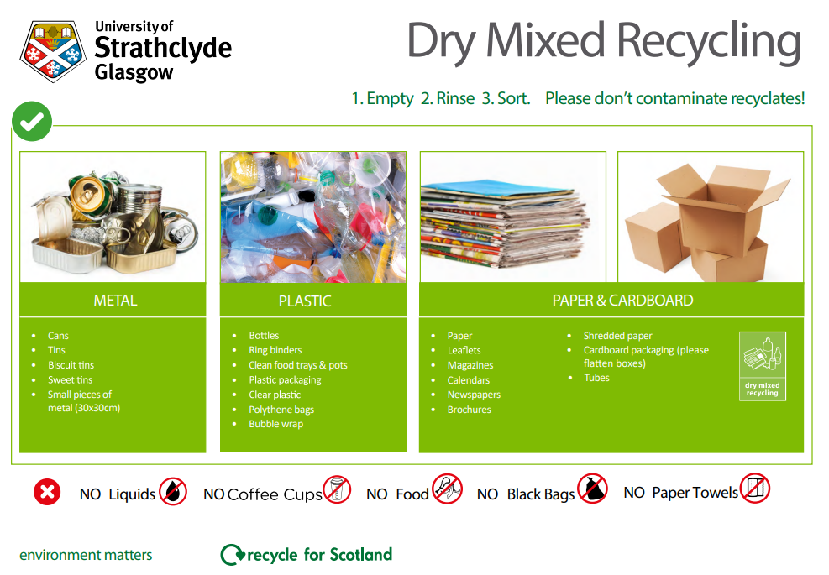

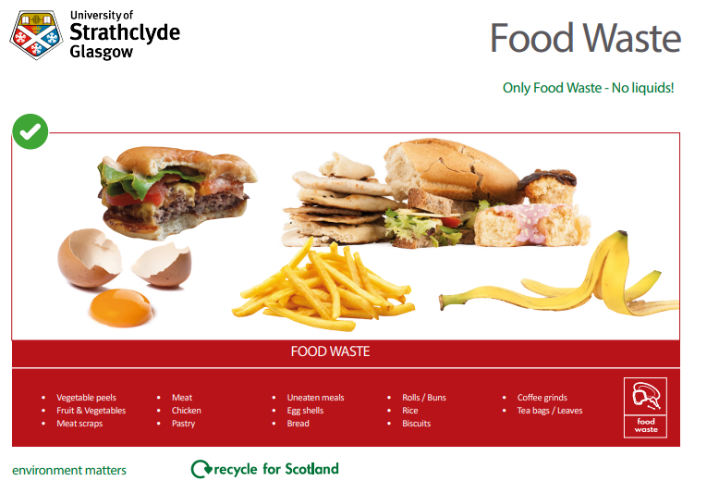

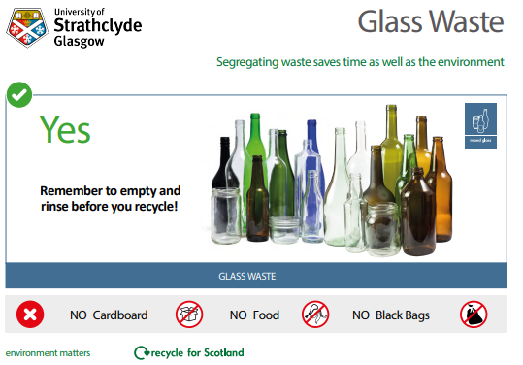

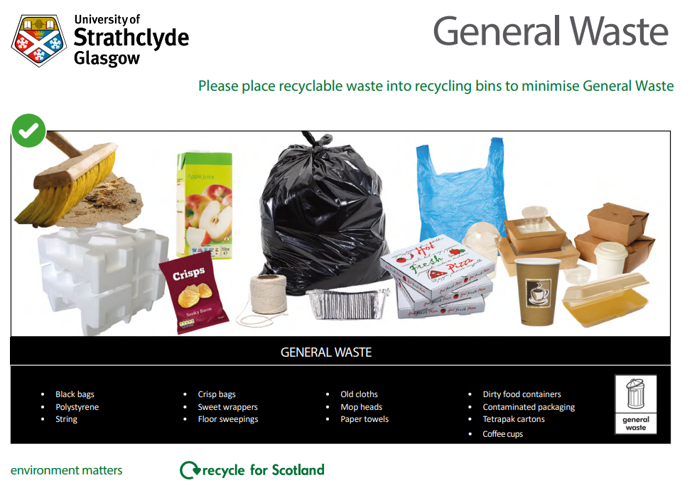

# What Happens to Our Waste?

**The main commercial waste contract for the university is currently held by Enva Scotland Ltd. Waste is collected from university facilities by Enva in a number of containers ranging from 240ltr standard wheeled bins up to 40 yard skips depending on the material type and volume. For the main waste streams generated by the university, details on how waste is treated are included below.**

## Dry Mixed Recycling

Dry mixed recycling includes all paper, plastic, tins and cans collected from university premeses. These materials are collected together by Enva typically in 1100ltr wheeled bins outside buildings and are taken to Enva’s Linwood depot and fed through thier Dry Mixed Recycling MRF, which screens and removes non-target materials and contamination, bailing the sorted and segregated materials as below:

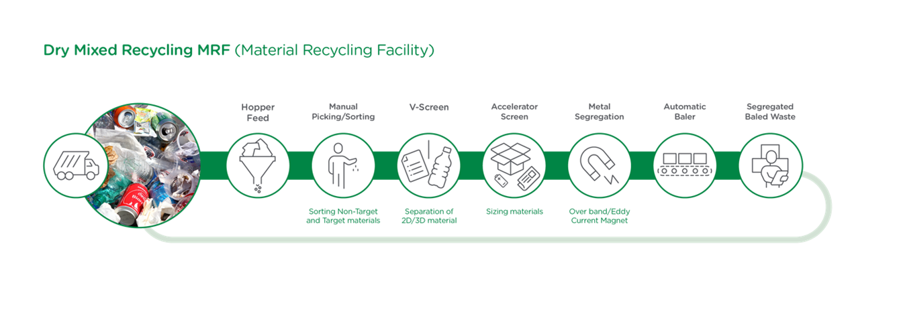

Bailed materials are then shipped to manufacturers who use them in the creation of new products, including newspapers, toilet roll and packaging products,

## Food waste

Food waste generated by the university is collected from buildings in 240ltr bins. It is taken to an anerobic digestion plant in Cumbernauld. This plant breaks down food waste in large tanks through the use of specially added bacteria in the absence of oxygen, creating a biogas which is used as a green energy source, and a solid material known as “digestate” whcih can be used as a soil enhancer for farming.

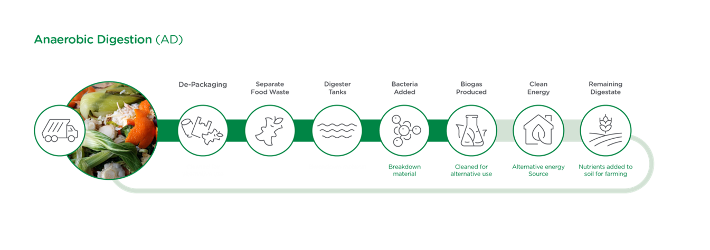

## General waste

Waste disposed of via general waste bins is collected by Enva in 1100ltr bins. It is taken to Enva’s Lindoowd Depot and storted, with large cardboard, timber textiles, metals end recyclables removed before it is shredded, with remaining metals removed via magnet. The material is then bailed and transported to energy from waste plants where is it is burned to produce energy.

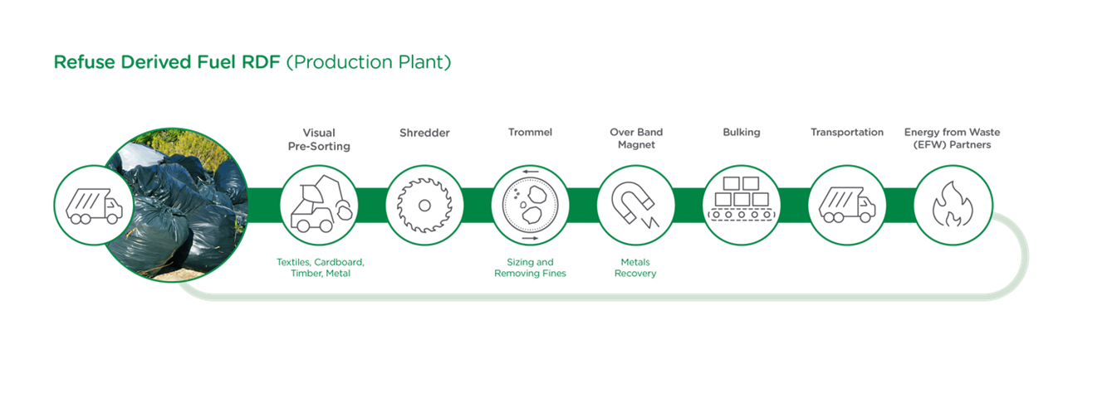

The university is aware that energy from waste is not an optimal waste disposal route, and is taking steps to reduce overall waste production but also increase recycling levels. As well as the environmental benefits to reducing and recycling waste, material disposed of via recycling routes is approximately 38% cheaper to treat than disposal through the general waste stream, so significant financial savings can also be made from more sustainable treatment.

The university will focus on reducing overall waste generation where practicable, and increasing the percentage reused or recycled over incineration or RDF.