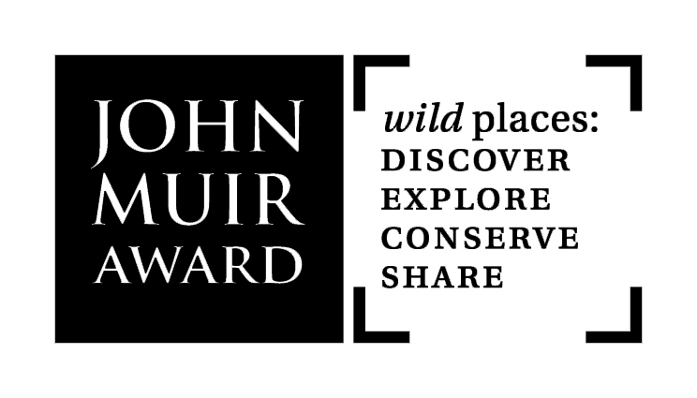
John Muir Award Four Challenge Review

Name of individual/ group:

To gain a John Muir Award everyone meets Four Challenges – Discover, Explore, Conserve, Share
This Four Challenge Review can help Award participants review and demonstrate that they have understood and successfully met the Award Challenges. Capture informally through group and individual discussion. Use pictures and drawings, write on flip chart, or a combination of these. Or just have a chat.

Discover  a wild place  What wild places have you discovered?  What did you like or not like about the wild places you visited?  What’s special about them? |  |  | Explore  its wildness  What have you done to get to know wild places? How have you experienced them?  What things have you found out?
Conserve  take Responsibility  How have you taken responsibility?  What have you done to make a difference and put something back for wild places? |  |  | Share  your experiences  Who have you shared with?  How have you shared your experiences of wild places?  What things have you thought about?  How do wild places make you feel?

