 |  | 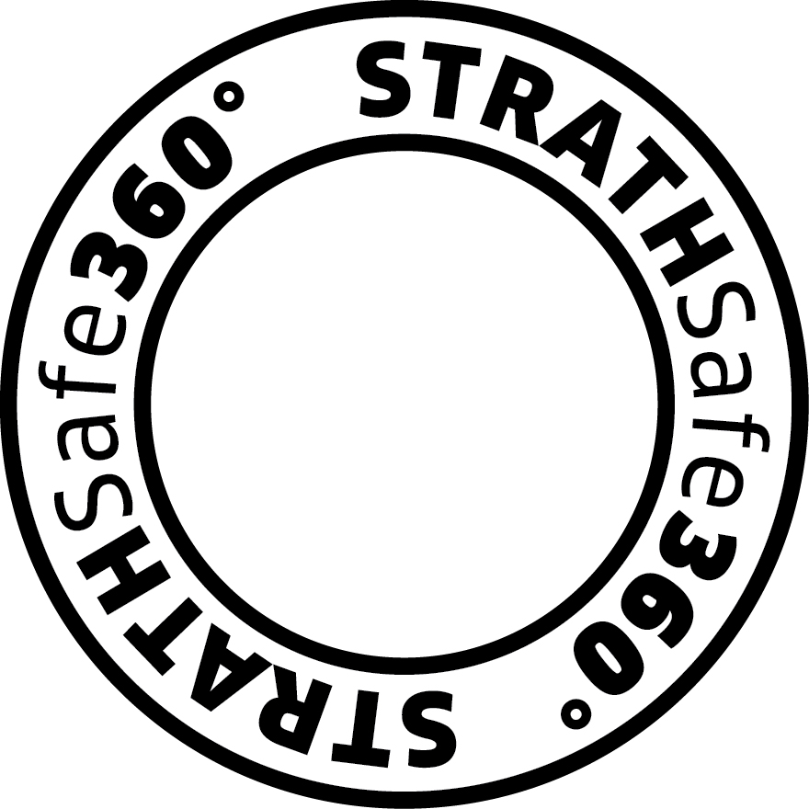

Data Management Plan (DMP) – generic template  This template is partially based on the Digital Curation Centre’s Checklist for a Data Management Plan.  Links to Strathclyde-specific platforms and services are included, where indicated (i.e.). | 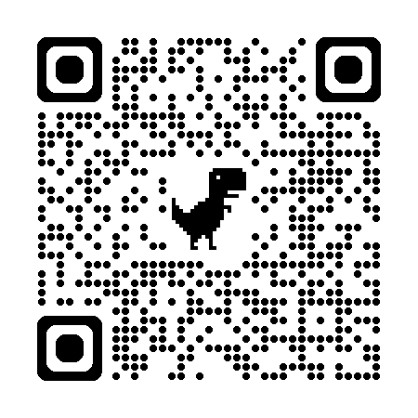  Scan for digital version

Project Name /Title:
Researcher name:
Funder:
Supervisor:
Department:
Date of First Version:
Date of Updates:

Data Collection - what data (file types) will be collected and generated during the project?
Please add details of data (files) in the table below; examples are given on the first four rows.
Data (file) type | Original format | Preservation format* | Does data (file) contain personal, or sensitive data? | Intellectual Property Rights (IPR) owner | Active storage location | Completed storage location (post-project)
Experiment notes | .xlsx, .docx | .csv, .rtf | No | UoS (University of Strathclyde) | i: drive | Pure
Microscope images | TIFF | Original | Yes | Company X | OneDrive for Business | Pure
Paper notebook | Paper | PDF | No | UoS | Cabinet in dept. | Pure
Audio recordings | .wav | .wav | Yes | UoS | OneDrive for Business | n/a – files will be deleted after transcription
*Preservation formats should be easy to access without the need for specific proprietary software.
How will the data be collected or created in the project?
Outline how data will be collected and /or generated; for example, from participant interviews; an online survey, using Qualtrics; from analysis of existing /secondary data sources; via equipment, Scanning Electron Microscope. Also, in this section, consider the following points:
- How will the data (files and folders) be organised, and file names applied? For example, create distinct folders based on workstreams, and separate folders for raw and processed data, to distinguish data types.
- How will you manage file versioning (e.g., first version of project DMP file: DMPv1.docx; if minor changes are made: DMPv1.2.docx; where significant changes are made: DMPv2.docx)
- What quality assurance processes will you adopt (e.g. double-checking results)?
- Will any third-party tools, platforms, or equipment be used to collect data? If so, name these in the DMP.
- The University’s Information Security Policy advises that personal and /or sensitive data should not be held in unencrypted storage platforms: please check that any third-party platforms or tools used for collecting data are permissible and offer robust security before use.
[Write your answer here]

Documentation and Metadata - What documentation and metadata will accompany the data?
What is data documentation?
Documentation helps others to understand the provenance and background to research data; examples of documentation might include a survey questionnaire or interview schedule - because they provide context to the answers and feedback collected from the respondents.
Electronic and paper lab notebooks and readme files offer a mechanism for documenting data; as would, for example, a codebook, which lists and explains variables and scales used.
What is metadata?
Metadata is effectively ‘data about data’, often ‘intended for reading by machines, metadata helps to explain the purpose, origin, time references, geographic location, creator, access conditions and terms of use of a data collection' (UK Data Service, Metadata).
Why are documentation and metadata important /required?
Rich, meaningful documentation and metadata help to make your dataset(s) discoverable and re-usable to the wider research community, as per the FAIR (Findable, Accessible, Interoperable, and Re-usable) Principles.
Briefly outline how will you capture and create documentation and metadata.
[Write your answer here]

Ethics and Legal Compliance - How will you manage legal and ethical issues?
Ethics and data protection are often linked because they usually involve collaborating with human participants; however, they are matters which need to be addressed separately.
Re: Ethics - Ethics and sponsorship approvals are required for all research involving human beings as participants, their data, and the use and/or collection of human biological tissue and/or fluid. The process of recruiting research participants and collecting their data must not begin until such approvals are in place.
Whatever is agreed as part of the ethics approval process should be mirrored in the respective project DMP and in how data (files) are managed. The University Ethics Committee website has guidance: a Code of Practice on Investigations Involving Human Beings and templates for use when drafting Consent forms, Participant info sheets, and Privacy notices for your project.
Re: Data Protection - Researchers must comply with the legislation when processing ‘personal data,’ i.e., data which relates to identified/identifiable living individuals. Please consult the Information Governance Unit’s guidance on Data Protection and Research, and outline how you (research team) will handle and protect ‘personal data’. Please note that using the standard University consent forms, PIS, and privacy notices will help you to ensure compliance with elements related to transparency and fairness.
In this section, please clarify the following and ignore any questions that are not relevant to your research:
- Are you submitting an ethics application?
- Will you collect and/or process personal data? If yes, please specify, what type of data this will be.
- Will you collect personal data that is also Special Category data (i.e. data relating to: racial or ethnic origin; political opinions; religious or philosophical beliefs; trade union membership; genetic data; biometric data (where used for identification purposes); health; sex life; and sexual orientation)? If yes, please specify the category.
- Will you process other particularly sensitive information, e.g. criminal conviction/offence data? If yes, please specify what type of data this will be.
- What steps will you take to protect research participants’ data (e.g., anonymisation)?
[Write your answer here]

Copyright and IPR issues
Re: copyright ownership - When a person authors a paper, creates a drawing, takes a photograph, they automatically own the copyright of this. In the same way, if you use existing/secondary data - created by others in your research - you need to acknowledge this. Moreover, if you create new data from your use of existing and/or secondary data sources, you must adhere to any third-party licence and/or re-use agreements.
Re IPR (Intellectual Property Rights) - These are relevant when a study/project works with data that contains protectable data not in the public domain; this is usually of commercial value, belonging to a company or organisation (e.g., Irn Bru - case study). Commercially sensitive or safeguarded data must be restricted accordingly
When a Strathclyde researcher deposits their dataset in Pure, following project completion, the default licence applied is CC BY 4.0. Anyone who uses a dataset with a CC BY 4.0 licence must 'must give appropriate credit, provide a link to the license, and indicate if changes were made'. You can choose a different licence be applied to your dataset, as befits any project contract, or ethical agreement.
In this section consider the following points (ignore any questions that are not relevant):
- If you will use secondary data, are there any restrictions on how you can reuse this?
- Are you collaborating with a company or commercial partner?
- Have you asked participants to create materials for the research, e.g., Photovoice, or diary? If so, do you plan to publish these?
[Write your answer here

Storage and Backup – Where will data be stored during the research project, and how will you manage access, back-ups, and security?
The University has secure file storage and sharing platforms which are automatically backed-up throughout the day. There is a File Storage Selector tool to help you find the most suitable platform for your research. In this section consider the following points (and ignore any questions that are not relevant):
- Where will you store the data (files) during your project/study?
- How will data be transferred to the University’s network/storage platforms if it originates from another location?
- How will you share files with your supervisors and /or project collaborators?
- NB: Before sharing data (files) out-with the University (e.g., with external partners, collaborators, transcription service) during an active project, you must check with the PI /Supervisor that this does not breach any contractual agreement, and that appropriate access and security controls are in place. Moreover, where this includes ‘personal data’, you must implement appropriate data protection clauses; this may require a Data Sharing and/or Data Processing Agreement.
[Write your answer here]

Data Curation and Open Access to Data – plans for preparing data for preservation (i.e., following project completion or publication) and making it ‘open.’
At, or near to project completion, or following publication, Strathclyde researchers must upload the (completed) data associated with project/s, publications, theses, etc. to the University’s institutional data repository in Pure, so that it can be catalogued, preserved, and, if appropriate, made openly accessible from the KnowledgeBase Research Information Portal
If uploading data to an external data repository (e.g., UK Data Service; GitHub) you must create a record (with metadata and a persistent link, e.g., DOI) in Pure, so that the University can record compliance with any funder mandate and keep track of the data.
Researchers should consider the following when selecting data for curation and preservation:
- Which data (files) underpin your thesis, publications?
- Does the data need to be ‘cleaned’ or anonymised before deposit into a data repository?
- Are there any other data (files) which do not underpin a publication/s, but are of value?
- Which data (files) will be shared openly?
- When will you make these data openly available?
- How will data be preserved and shared publicly (e.g. preserved in Pure and made publicly available via the KnowledgeBase – the public portal of Pure?).
- If data are unsuitable for deposit in a data repository and/or being made open access, please outline why this is so, for example, confidentiality clause; safeguarding concerns; contains personal data, i.e. individuals are identified/identifiable.
[Write your answer here]

Are any restrictions to data sharing, i.e., ‘open data’ sharing required?
When drafting a DMP, it is helpful to differentiate between the data sharing which may take place between student and supervisor, and project members /partners during the project timeline, from the data sharing which takes place after a project completes, or along with a publication, i.e., what many funders and publishers’ term, ‘open data sharing’ or open access data. Open data sharing is often a requirement of public funding.
In some cases, (completed) research data may not be suitable for publication and may need to be restricted. For example, if it contains personal data; protectable intellectual property (IP); there are plans to commercialise the research; it is otherwise confidential /sensitive or, if there are safeguarding concerns.
NB. If you intend to make research data that includes personal data, i.e. data relating to identified/identifiable living individuals, accessible to others/outside the University, you must ensure, in advance, that you can do so lawfully. You should consult the University’s Information Governance Unit in advance with any queries.
If data relates to a patent application it should not be uploaded to Pure, or any other data repository, nor shared, until such times as clearance has been given by the Principal Investigator, Supervisor, and/or the University’s IP & Commercialisation staff.
Please confirm if the research data can be shared openly after project completion (or along-with publication) and if not, explain why.
[Write your answer here]

Responsibilities and Resources - Who is responsible for data management?
Please confirm who is responsible for implementing the DMP, and for ensuring it is reviewed and revised regularly?
[Write your answer here]

What resources will you require to look after and manage research data?
- Is any additional specialist expertise (or training for existing staff) required?
- Do you require hardware or software which is additional to existing institutional provision?
[Write your answer here]
NB. Help with preparing a DMP, including review and feedback on draft DMPs, is available on request to the RDMS Specialist. The provisional and final version of a project DMP should be uploaded to the DMP Inbox (or Neptune or SPIDER) - as per the requirements of the RDMS Policy.

